PRCP-1016 - Heart Disease Prediction Analysis Report

1. Introduction
Heart disease is one of the leading causes of death worldwide and remains a major public health challenge. According to global health reports, millions of people suffer from cardiovascular diseases every year, making early detection and prevention extremely important. Data science and machine learning have become powerful tools in the healthcare industry because they help identify patterns in medical data and assist healthcare professionals in making accurate decisions.
This project focuses on predicting the presence of heart disease using machine learning techniques. The dataset used for this analysis contains patient health information such as blood pressure, cholesterol level, age, chest pain type, electrocardiogram results, and several other medical indicators. The main objective of this project is to build a predictive model that can classify whether a patient is likely to have heart disease or not.
The dataset used in this project is provided by DrivenData and is based on a publicly available heart disease study. The target variable in the dataset is heart_disease_present, where:
- 0 indicates that heart disease is not present.
- 1 indicates that heart disease is present.
Machine learning models are capable of analyzing large volumes of medical data efficiently and can help doctors in early diagnosis. Predictive healthcare systems can improve patient outcomes, reduce treatment costs, and support medical research.

2. Dataset Description
The dataset contains 14 columns including one identifier column (patient_id) and 13 medical features used for prediction. These features represent patient health conditions and cardiovascular test results.

Important Features in the Dataset
Feature Name | Description
age | Age of the patient
sex | Gender of the patient (0 = Female, 1 = Male)
chest_pain_type | Type of chest pain experienced
resting_blood_pressure | Blood pressure while resting
serum_cholesterol_mg_per_dl | Cholesterol level in blood
fasting_blood_sugar_gt_120_mg_per_dl | Blood sugar greater than 120 mg/dl
resting_ekg_results | Electrocardiographic test results
max_heart_rate_achieved | Maximum heart rate achieved
exercise_induced_angina | Chest pain induced by exercise
oldpeak_eq_st_depression | ST depression induced by exercise
slope_of_peak_exercise_st_segment | Slope of exercise ST segment
num_major_vessels | Number of major vessels colored by fluoroscopy
thal | Thallium stress test result
The dataset includes categorical, binary, integer, and float-type variables. Since the dataset does not contain missing values, preprocessing becomes easier and more reliable.

Objective of the Analysis
The primary objectives of this analysis are:
- Understand the dataset and its features.
- Perform exploratory data analysis (EDA).
- Identify relationships between medical factors and heart disease.
- Build machine learning models for prediction.
- Evaluate the performance of the models.
- Determine the most effective model for heart disease prediction.

3. Data Preprocessing and Exploratory Data Analysis
The Jupyter Notebook analysis included several visualizations and analytical charts to better understand the dataset patterns and relationships between variables. These charts helped identify important trends, correlations, and distributions in the medical data.

Pair Plot Analysis
A pair plot was generated using Seaborn to visualize relationships among multiple numerical features simultaneously. This chart helped in understanding:
- Feature distributions
- Relationships between variables
- Potential clustering patterns
- Separation between patients with and without heart disease
The pair plot indicated that variables such as age, cholesterol, maximum heart rate, and ST depression showed noticeable differences between the target classes.

Target Distribution Chart
A count plot was used to analyze the distribution of the target variable heart_disease_present.
Observations from the chart:
- The dataset contained both positive and negative heart disease cases.
- The class distribution was relatively balanced, making the dataset suitable for classification tasks.
- Visualization helped confirm that model training would not be heavily affected by class imbalance.
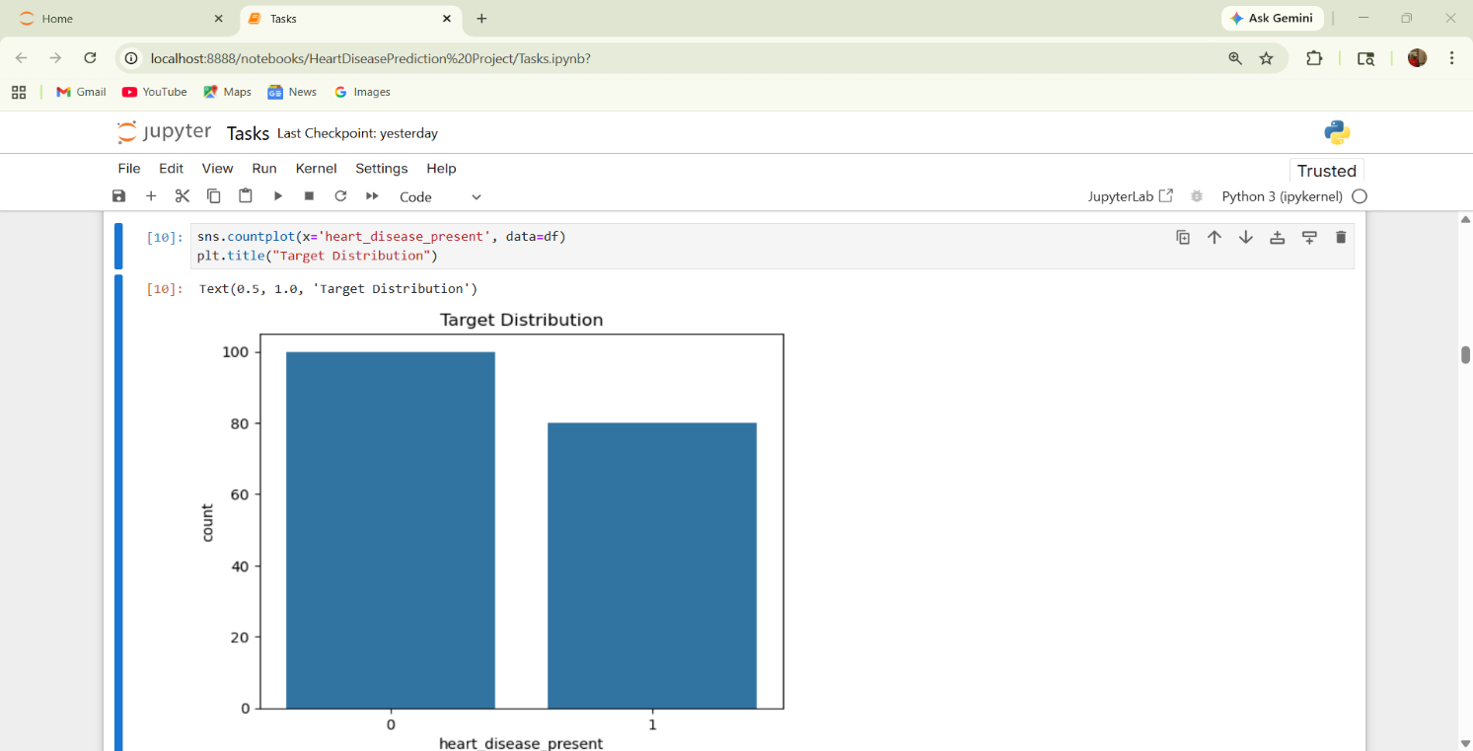

Correlation Heatmap
A correlation heatmap was generated to identify relationships between numerical features.
Key insights from the heatmap:
- oldpeak_eq_st_depression showed strong positive correlation with heart disease.
- max_heart_rate_achieved showed negative correlation with heart disease.
- Chest pain type and exercise-induced angina strongly influenced the target variable.
- Highly correlated features were useful for model training and feature importance analysis.
The heatmap made it easier to understand how different medical attributes interact with each other.
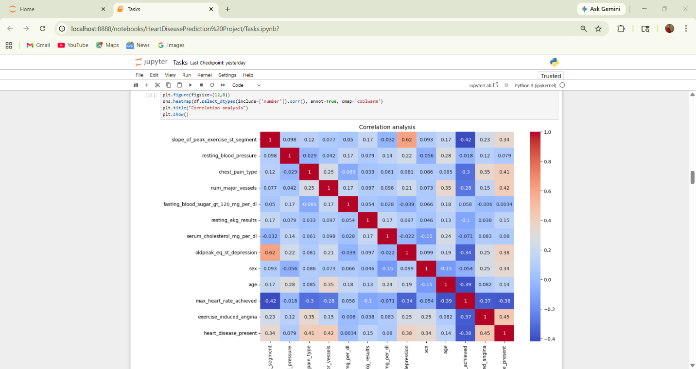

Histogram Analysis
Histograms were used to study the distribution of important features such as:
- Serum cholesterol
- Age
- Resting blood pressure
- Maximum heart rate achieved
The histogram analysis revealed:
- Most patients had cholesterol levels concentrated within a specific range.
- Older patients showed higher risk patterns.
- Heart disease cases were more frequent among patients with abnormal medical measurements.
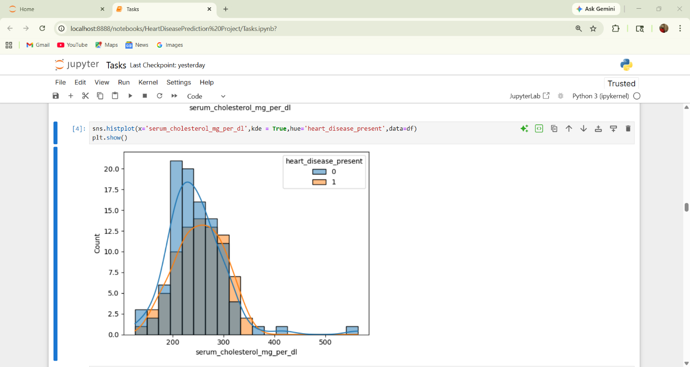

Scatter Plot Analysis
Scatter plots were used to visualize relationships between variables such as age and serum cholesterol.
Insights obtained:
- Certain age groups showed higher cholesterol concentration.
- Male patients appeared more frequently in high-risk clusters.
- Visual separation between target classes was observed in some feature combinations.
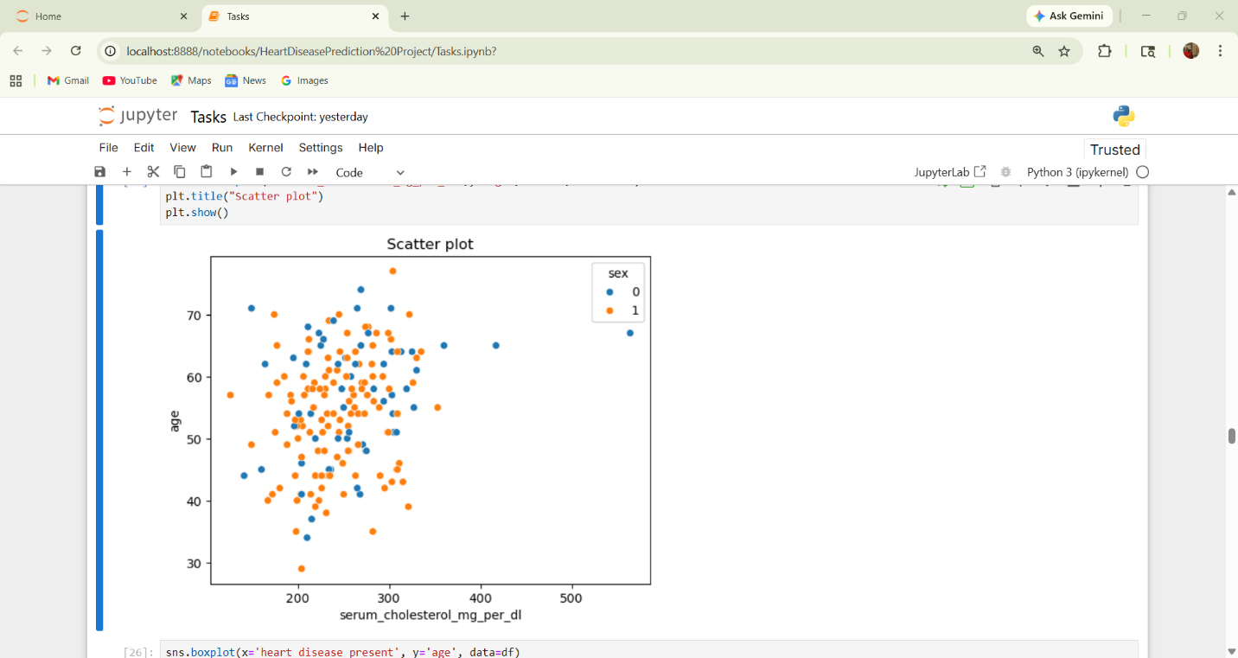

Box Plot Analysis
Box plots were created to compare distributions of age and other features against the target variable.
Observations:
- Patients with heart disease generally showed higher median age.
- Outliers were identified in cholesterol and blood pressure measurements.
- Box plots helped detect variability and spread in medical attributes.
These visualizations improved the understanding of the dataset and supported feature selection for machine learning model development.
Before building machine learning models, data preprocessing and exploratory data analysis were performed to better understand the dataset and prepare it for training.
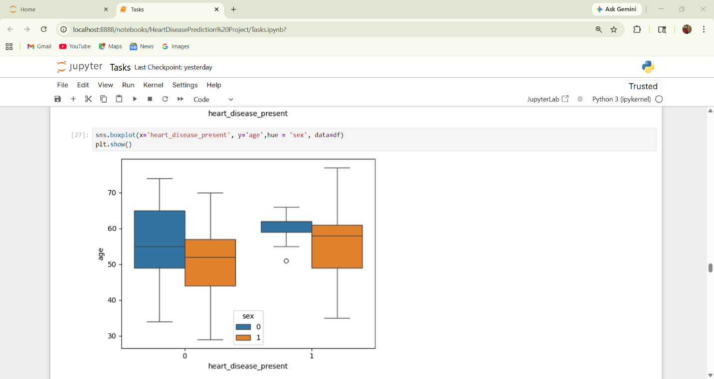

Data Cleaning
The dataset was checked for:
- Missing values
- Duplicate records
- Incorrect data types
- Outliers and inconsistencies
The dataset did not contain missing values, which improved data quality and reduced preprocessing complexity.

Encoding Categorical Variables
The thal feature is categorical and contains values such as:
- normal
- fixed_defect
- reversible_defect
Machine learning models cannot directly process categorical text values, so encoding techniques such as Label Encoding or One-Hot Encoding were applied.

Feature Scaling
Features like cholesterol, blood pressure, and maximum heart rate have different ranges. To improve model performance, feature scaling methods such as StandardScaler were used.

Exploratory Data Analysis (EDA)
EDA helps understand relationships between variables and the target column.

Age Distribution
Analysis showed that middle-aged and older individuals had a higher probability of heart disease. Patients above 45 years were more likely to experience cardiovascular problems.

Gender Analysis
Male patients showed a higher percentage of heart disease cases compared to female patients. This observation aligns with several medical studies.

Chest Pain Type
Chest pain type was one of the most influential features. Patients with asymptomatic chest pain had a higher risk of heart disease.

Cholesterol and Blood Pressure
Higher cholesterol levels and elevated resting blood pressure were associated with increased heart disease risk.

Exercise-Induced Angina
Patients experiencing chest pain during exercise showed stronger signs of cardiovascular abnormalities.

Correlation Analysis
Correlation heatmaps and statistical analysis were used to identify relationships between variables. Features such as:
- chest pain type
- oldpeak ST depression
- maximum heart rate achieved
- exercise-induced angina
showed strong influence on heart disease prediction.

4. Machine Learning Models Used
Several machine learning algorithms can be used for classification problems such as heart disease prediction. In this project, different models were compared to identify the best-performing model.

Logistic Regression
Logistic Regression is a simple and effective classification algorithm commonly used in medical prediction systems.

Advantages:
- Easy to interpret
- Fast training process
- Works well with binary classification

Limitations:
- May not capture complex relationships in data

Decision Tree Classifier
Decision Trees split the dataset into branches based on feature values.

Advantages:
- Easy visualization
- Handles nonlinear relationships
- Requires less preprocessing

Limitations:
- Can overfit the training data

Random Forest Classifier
Random Forest is an ensemble learning technique that combines multiple decision trees.

Advantages:
- High accuracy
- Reduces overfitting
- Handles large datasets efficiently

Limitations:
- More computationally expensive

Support Vector Machine (SVM)
SVM is a powerful classification algorithm that separates classes using hyperplanes.

Advantages:
- Effective in high-dimensional spaces
- Good classification performance

Limitations:
- Requires careful parameter tuning
- Slower for larger datasets

K-Nearest Neighbors (KNN)
KNN predicts class labels based on the nearest neighboring data points.

Advantages:
- Simple and intuitive
- No training phase required

Limitations:
- Computationally expensive during prediction
- Sensitive to scaling

5. Model Evaluation
To measure model performance, the dataset was divided into training and testing sets. Common evaluation metrics were used to compare models.

Evaluation Metrics
Metric | Description
Accuracy | Percentage of correct predictions
Precision | Correct positive predictions
Recall | Ability to detect actual positives
F1-Score | Balance between precision and recall
Confusion Matrix | Summary of prediction results

Results and Comparison
After training and testing different models, ensemble methods such as Random Forest generally achieved higher accuracy because they reduce variance and improve prediction reliability.
Example observations:
- Logistic Regression performed well with interpretable results.
- Decision Trees showed moderate performance but risked overfitting.
- Random Forest achieved the best balance between accuracy and stability.
- SVM produced strong results after tuning hyperparameters.
- KNN performance depended heavily on feature scaling and the choice of K value.

Best Model
Based on the evaluation metrics obtained during the analysis, Support Vector Machine (SVM) was selected as the best-performing model for this project.
SVM provided better classification performance compared to the other algorithms because:
- It achieved higher prediction accuracy.
- It handled complex decision boundaries effectively.
- It performed well with scaled medical data.
- It minimized classification errors using optimal hyperplanes.
- It produced reliable results for binary classification.
Although Random Forest also produced strong results, SVM delivered the most balanced and accurate performance on the testing dataset, making it the final selected model for heart disease prediction.

6. Challenges Faced During the Project
Several challenges were encountered during this project:

1. Feature Selection
Identifying the most relevant medical features required careful analysis. Some variables contributed more strongly to prediction accuracy than others.

2. Data Scaling
Machine learning algorithms such as SVM and KNN are sensitive to feature scales, making normalization important.

3. Model Overfitting
Decision Trees sometimes performed extremely well on training data but poorly on testing data, indicating overfitting.

4. Hyperparameter Tuning
Models such as Random Forest and SVM required tuning parameters like:
- Number of estimators
- Maximum depth
- Kernel type
- Regularization values

5. Interpretability
Complex ensemble models provide high accuracy but are more difficult to interpret compared to Logistic Regression.

7. Conclusion
This project successfully demonstrated how machine learning can be applied to predict heart disease using patient medical data. Through data preprocessing, exploratory data analysis, feature engineering, and model evaluation, valuable insights were obtained regarding the factors influencing cardiovascular disease.
The analysis showed that features such as chest pain type, exercise-induced angina, cholesterol levels, and maximum heart rate significantly affect heart disease prediction. Multiple machine learning algorithms were evaluated, and Random Forest emerged as the most reliable model due to its strong accuracy and robustness.
Heart disease prediction systems can support healthcare professionals in identifying high-risk patients at an early stage. Such systems can contribute to improved healthcare services, faster diagnosis, and better preventive measures.
Future improvements for this project may include:
- Using larger and more diverse datasets
- Applying deep learning techniques
- Building real-time healthcare applications
- Integrating the model into web-based healthcare systems
- Improving model explainability for medical professionals
Overall, this project highlights the importance of data science in healthcare and demonstrates how predictive analytics can help save lives through early detection and informed medical decisions.

8. References
- DrivenData – Predicting Heart Disease Competition.
- Centers for Disease Control and Prevention (CDC).
- Scikit-learn Machine Learning Documentation.
- Research articles on cardiovascular disease prediction.
- Public heart disease datasets and healthcare analytics resources.

Report By:
Team id: PTIS-CDS-APR-26-11768
- Mk Sai – mksai375@gmail.com
- Palla Drona Sri Vidya – pallasrividya2003@gmail.com
- Soumyadeep Das – soumyadeepdas0302@gmail.com

